NAME:SHERALI

SECTION:BSCS-1

ROLLNO:P21-8024

**QUESTION1:**

AL=input("Enter a character:")

if(AL=="A" or AL=="a"or AL=="E" or AL=="e" or AL=="I" or AL=="i" or AL=="O" or AL=="o" or AL=="U"

or AL=="u"):

print(AL, 'is a vowel')

else:

print(AL, 'is a constant')

**INPUT:**

**OUTPUT:**

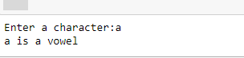

**QUESTION2:**

**INPUT:**

x=int(input("Enter the first value"))

y=int(input("Enter the second value"))

z=int(input("Enter the third value"))

if x == y == z :

print("Equalateral Triangle")

elif x==y or y==z or z==x :

print("Isosceles Triangle")

else:

print("scalene Triangle")

**OUTPUT:**

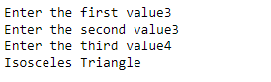

**QUESTION3:**

**INPUT:**

number1=int(input("Enter the first number"))

number2=int(input("Enter the second number"))

print("for addition press 1\nfor subtraction press2\nfor multiplication press 3\nfor division press4\n")

entry=int(input("Enter entry for operation"))

if entry==1:

print("addition", number1+number2)

elif entry==2:

print("subtraction", number2-number1)

elif entry==3:

print("multiplication", number1*number2)

elif entry==4:

print("division", number1/number2)

else:

print(nothing)

**OUTPUT:**

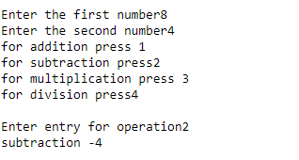

**QUESTION4:**

**INPUT:**

def largest_odd(x,y):

if x%2 and y%2 != 0:

print(max(x,y),"is greatest odd number")

elif x%2==0 and y%2 != 0:

print(y,"is greatest odd number")

elif x%2 != 0 and y%2==0:

print(x,"is greates odd number")

else:

print("none of them are odd")

largest_odd(20,21)

**OUTPUT:**

